Item | Details
Project Name | Home Service Management System
Version | 1.0
Author | Joel Binu Philip
Status | Final
Service Management System
Design Document
Purpose :-
This document describes the system architecture, design decisions, component structure, APIs, data models, and non-functional aspects of the Service Management System. It is intended for:
- Developers
- Reviewers
- Interview discussions
- Maintenance & enhancement planning

SYSTEM OVERVIEW
Business Objective
Provide a scalable, secure, and maintainable system to:
- Manage users: Handle customer registration, authentication, and profiles securely.
- Manage services: Maintain a dynamic catalog of home services with categories and pricing.
- Book and track services: Enable users to schedule services and track status from pending to completion.
- Assign Technicians: Intelligently assign tasks to field technicians based on skills and availability.
- Process Payments: Generate invoices and track revenue for completed jobs.
- Support growth: Leverage microservices architecture for independent scaling and modularity.
High-Level Features
- User registration & login: Multi-role support (Customer, Technician, Manager, Admin) with JWT security.
- Service catalog management: Admin-controlled categories and service listings.
- Booking lifecycle: Create bookings, assign technicians, track progress, and complete jobs.
- Technician management: Profile approval workflow and workload balancing.
- Notification system: Real-time email alerts for booking updates and invoicing.
Architecture Overview
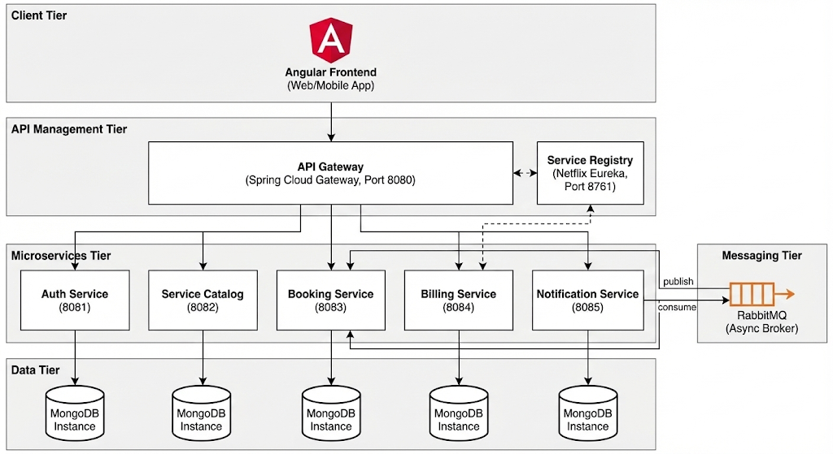

Architecture Style
- Microservices Architecture: Decomposed into loosely coupled, independently deployable services.
- REST-based & Event-driven communication: Synchronous API calls (OpenFeign) combined with asynchronous messaging (RabbitMQ).
- API Gateway Pattern: Centralized entry point for routing, security, and cross-cutting concerns.
- Service Discovery: Dynamic registration and discovery of microservice instances.
- Database per Service: Each microservice owns its own data source to ensure decoupling.
- Containerized deployment: Designed for deployment using Docker containers.
Core Components
- Angular Frontend: Single Page Application serving as the user interface for all roles.
- API Gateway: Spring Cloud Gateway acting as the single entry point (Edge Server).
- Service Registry: Netflix Eureka for microservices discovery and load balancing capabilities.
- Auth Service: Manages user identity, authentication (JWT), and technician profiling.
- Service Catalog: Manages the hierarchy of service categories and individual service items.
- Booking Service: Handles the core lifecycle of service requests, assignments, and dashboard data.
- Billing Service: Manages invoice generation and revenue tracking upon booking completion.
- Notification Service: Sends asynchronous alerts via email using event triggers.
- Message Broker: RabbitMQ for handling asynchronous events between services.
- MongoDB Instances: Separate NoSQL databases for each microservice.
- CI/CD Pipeline: Automated build, test, and deployment workflow (e.g., Jenkins/GitHub Actions).
TECHNOLOGY STACK
- Backend - Core & Frameworks
- Java 17: Primary programming language.
- Spring Boot 3.2.x: Rapid application development framework.
- Spring Web (MVC): For building RESTful APIs.
- Spring Data MongoDB: For MongoDB persistence and object mapping.
- Spring Validation (Hibernate Validator): For request payload validation.
- Spring Security: For authentication and authorization capabilities.
- JJWT (Java JWT): For generating and validating JSON Web Tokens.

Backend - Microservices Ecosystem (Spring Cloud)
- Spring Cloud Gateway: API Gateway and edge service.
- Netflix Eureka: Service discovery and registration server.
- Spring Cloud OpenFeign: Declarative REST client for inter-service communication.
- Resilience4j: Fault tolerance library (Circuit Breakers, Retry).
- Spring AMQP (RabbitMQ): For asynchronous messaging integration.

Frontend
- Angular (v16+): Component-based web application framework.
- Bootstrap 5: CSS framework for responsive styling and UI components.
- RxJS: Reactive extensions for handling asynchronous data streams.

Database & Messaging
- MongoDB (v6.0+): NoSQL document database (Pattern: Database-per-service).
- RabbitMQ: Message broker for event-driven architecture.

DevOps & Infrastructure
- Docker: Containerization platform.
- Docker Compose: Tool for defining running multi-container applications locally.
- GitHub Actions / Jenkins: For Continuous Integration and Deployment (CI/CD) pipelines.
- SonarQube: For continuous code quality inspection.

Testing
- JUnit 5: unit testing framework for Java.
- Mockito: Mocking framework for unit tests.
- Spring Boot Test (MockMvc): Integrated testing for Spring Boot applications.

6. MICROSERVICES DESIGN
6.1 Auth Service (Port: 8081)
Responsibilities:
- User registration (Customer, Technician)
- JWT token generation & validation
- Technician profile management (Skills, Experience, Approval)
- Audit logging
APIs:
Method | Endpoint | Access | Description
POST | /api/auth/login | Public | User login, returns JWT ²⁶
POST | /api/auth/register/customer | Public | Customer registration ²⁷
POST | /api/auth/register/technician | Public | Technician registration (Pending approval) ²⁸
POST | /api/auth/refresh | Public | Refresh expired access token ²⁹
GET | /api/service-manager/technicians | Manager | Get technicians for approval/assignment ³⁰
POST | /api/service-manager/approve/{id} | Manager | Approve technician profile
Sample Payload (Technician Register):
JSON
{
"username": "tech_john",
"email": "john@tech.com",
"password": "Password@123",
"skills": ["AC Repair", "Electrical"],
"experienceYears": 5,
"idProofType": "AADHAAR"
}
6.2 Service Catalog (Port: 8082)
Responsibilities:
- Manage service categories (e.g., Cleaning, Plumbing)
- Manage service items and base pricing
- Serve images and descriptions to frontend
APIs:
Method | Endpoint | Access | Description
GET | /api/services/categories | Public | List all service categories ³²
POST | /api/services | Admin | Create new service item ³³
GET | /api/services/{id} | Public | Get service details & pricing ³⁴
6.3 Booking Service (Port: 8083)
Responsibilities:
- Core booking lifecycle (Create -> Assign -> Complete)
- Dashboard analytics and reporting
- Technician workload management
APIs:
Method | Endpoint | Access | Description
POST | /api/bookings | Customer | Create service request ³⁵
GET | /api/bookings | Authenticated | Get user's bookings ³⁶
PUT | /api/bookings/{id}/assign | Manager | Assign technician to booking ³⁷
PUT | /api/bookings/{id}/complete | Technician | Complete service (OTP required) ³⁸
GET | /api/bookings/dashboard/stats | Manager | Get system-wide statistics ³⁹
Sample Payload (Create Booking):
JSON
{
"serviceId": "svc-101",
"problemDescription": "AC not cooling",
"scheduledDate": "2026-01-10T10:00:00",
"addressLine1": "123 Main St",
"city": "Bangalore",
"zipCode": "560001"
}
6.4 Billing Service (Port: 8084)
Responsibilities:
- Generate invoices upon service completion
- Calculate tax (GST) and discounts
- Track revenue
APIs:
Method | Endpoint | Access | Description
GET | /api/billing/invoices/{id} | Authenticated | Get invoice details ⁴⁰
POST | /api/billing/invoices/{id}/pay | Customer | Process payment ⁴¹
GET | /api/billing/reports/revenue | Admin | Get revenue reports ⁴²
6.5 Notification Service (Port: 8085)
Responsibilities:
- Listen to RabbitMQ events
- Send transactional emails (Welcome, Booking Confirmed, Invoice)
RabbitMQ Events:
Queue | Event | Trigger
notification.email | BookingEvent | Booking Created/Assigned/Completed ⁴³
notification.email | BillingEvent | Invoice Generated/Paid ⁴⁴

7. DATA DESIGN (LLD)
Auth Service DB - User Collection
Stores core user identity and authentication data.
JSON
{
"_id": "u101",
"username": "customer_alice",
"email": "alice@example.com",
"password": "$2a$10$EixZaYVK1fsbw1ZfbX3OXePaWrn9BaX10...encrypted...",
"roles": ["ROLE_CUSTOMER"],
"createdAt": "2026-01-07T10:00:00Z"
}
Auth Service DB - TechnicianProfile Collection
Stores additional details for users with the technician role.
JSON
{
"_id": "tp201",
"userId": "u102",
"skills": ["AC Repair", "Electrical"],
"experienceYears": 5,
"approvalStatus": "APPROVED",
"available": true,
"averageRating": 4.8,
"idProofType": "AADHAAR",
"idProofNumber": "XXXX-XXXX-1234"
}
Service Catalog DB - ServiceCategory Collection
Defines broad categories for services.
JSON
{
"_id": "cat301",
"name": "Plumbing",
"description": "All kinds of plumbing pipe and fixture services."
}
Service Catalog DB - ServiceItem Collection
Defines individual sellable services, linked to a category.
JSON
{
"_id": "svc401",
"categoryId": "cat301",
"name": "Leaky Faucet Repair",
"description": "Fixing dripping faucets in kitchen or bathroom.",
"basePrice": 450.00,
"imageUrl": "http://localhost:8082/images/faucet.jpg"
}
Booking Service DB - Booking Collection
The central transaction record representing a service request.
JSON
{
"_id": "bkg501",
"customerId": "u101",
"technicianId": "u102",
"serviceId": "svc401",
"status": "ASSIGNED",
"scheduledDate": "2026-01-10T14:00:00Z",
"bookingPriority": "MEDIUM",
"problemDescription": "Kitchen faucet is dripping constantly.",
"address": {
"line1": "Flat 402, Palm Heights",
"city": "Bangalore",
"zipCode": "560001"
},
"completionOtp": "4521",
"createdAt": "2026-01-07T11:30:00Z"
}
Billing Service DB - Invoice Collection
A snapshot of financial data for a completed booking.
JSON
{
"_id": "inv601",
"bookingId": "bkg501",
"customerId": "u101",
"issueDate": "2026-01-10T15:30:00Z",
"amount": 450.00,
"taxAmount": 81.00,
"discountAmount": 0.00,
"totalAmount": 531.00,
"paymentStatus": "PENDING"
}
Here are the final sections for your document, adapted to match the provided format and content of your project.
9. ERROR HANDLING STRATEGY
Global Exception Handling
- Centralized Handling: Implemented using @ControllerAdvice and @ExceptionHandler to catch and process exceptions across all controllers in a uniform way.
- Standardized Error Response: All microservices return a consistent JSON structure for errors, ensuring the frontend can parse and display messages predictively.
Standard error response format
JSON
{
"timestamp": "2026-01-07T10:00:00",
"status": 404,
"error": "Not Found",
"message": "Service with ID svc-999 not found",
"path": "/api/services/svc-999"
}
Validation Errors
For validation failures (e.g., missing fields), the response includes a detailed breakdown:
JSON
{
"timestamp": "2026-01-07T10:05:00",
"status": 400,
"error": "Validation Error",
"message": "Input validation failed",
"validationErrors": {
"basePrice": "must be greater than or equal to 0",
"name": "must not be blank"
},
"path": "/api/services"
}
SECURITY DESIGN
The system employs a multi-layered security approach to protect data and resources.
- JWT Authentication: State-less authentication mechanism. Upon successful login, a signed JSON Web Token (JWT) containing user identity and roles is issued. This token must be included in the Authorization: Bearer <token> header for subsequent API calls.
- Role-Based Access Control (RBAC): API endpoints are secured with PreAuthorize annotations (e.g., @PreAuthorize("hasRole('MANAGER')")) to ensure only users with the correct privileges can perform specific actions.
- API Gateway Security: The Spring Cloud Gateway acts as the first line of defense, centralizing CORS configuration to prevent unauthorized cross-origin requests.
- Password Encryption: User passwords are hashed and salted using BCrypt before storage in the MongoDB database, protecting them even in case of a data breach.
- Secure Service-to-Service Communication: Inter-service calls (e.g., Booking to Catalog) are made via authenticated internal APIs.
- Rate Limiting (Future Scope): Can be implemented at the Gateway level to prevent brute-force attacks.
11. NON-FUNCTIONAL REQUIREMENTS
Area | Design Decision
Scalability | Microservices architecture allows each service (e.g., Booking) to be scaled independently using Docker containers based on demand.
Performance | Pagination implemented for list APIs (e.g., getAllServices). Asynchronous communication via RabbitMQ decouples high-latency tasks like email notifications.
Availability | Decomposed services ensure that if one service (e.g., Notification) is down, core functionality like Booking can still operate. The API Gateway and Service Registry are critical components.
Maintainability | Clear separation of concerns with a layered backend architecture (Controller -> Service -> Repository). Each microservice has a single, focused responsibility.
Security | Input validation (JSR-303 annotations), JWT-based stateless authentication, BCrypt password hashing, and fine-grained RBAC.
Fault Tolerance | Circuit Breakers (Resilience4j) are used in Feign Clients to handle failures in dependent services gracefully and prevent cascading failures.
TESTING STRATEGY
A comprehensive testing strategy is employed to ensure the reliability, security, and functionality of the microservices and the frontend application.
Backend Testing (Java/Spring Boot)
Backend testing focuses on validating business logic, API contracts, and data access layers in isolation and integration.
- Unit Tests (Service Layer)
  - Uses JUnit 5 and Mockito.
  - Tests business logic within @Service classes in complete isolation by mocking dependencies (repositories, other services, Feign clients).
  - Ensures all edge cases and business rules (e.g., price calculations, status transitions) are covered.
- Controller Integration Tests (API Layer)
  - Uses Spring Boot Test and MockMvc.
  - Verifies REST endpoint URLs, HTTP methods, request body validation, and correct JSON response structures.
  - Mocks the underlying service layer to focus purely on web layer concerns.
- Repository Tests (Data Layer)
  - Uses @DataMongoTest to verify interactions with the MongoDB database, ensuring custom queries and data mapping are correct using an embedded test database.
- Code Coverage Goal
  - Minimum 90% line coverage for critical business logic in Service and Controller packages.
Frontend Testing (Angular)
Frontend testing ensures UI components behave correctly and client-side services handle data properly.
- Component Tests
  - Uses Jasmine and Karma.
  - Verifies that components render templates correctly, handle user interactions (clicks, form submissions), and update the view state appropriately.
- Service Tests
  - Tests Angular services in isolation using HttpTestingController to mock backend API calls.
  - Ensures data is correctly retrieved, transformed, and that error responses from the backend are handled gracefully.
Quality Gates & CI/CD
Automated quality checks are integrated into the build pipeline to prevent regressions and maintain code standards.
- Static Analysis & Code Quality
  - SonarQube is integrated into the CI pipeline (e.g., Jenkins) to scan code for bugs, vulnerabilities, and code smells on every push.
- Automated Build Failure
  - The build pipeline is configured to fail immediately if:
    - Any unit or integration test fails.
    - Code coverage drops below the defined threshold (e.g., 90%).
    - SonarQube Quality Gate detects critical or high-severity issues.

DEPLOYMENT STRATEGY
The system is designed for a cloud-native deployment using containerization and orchestration to ensure scalability and manageability.
Infrastructure & Containerization
- Docker: Each microservice (Auth, Booking, etc.), the API Gateway, Eureka Server, and the Angular Frontend are packaged into individual, lightweight Docker containers. This ensures consistency across development, testing, and production environments.
- Databases: MongoDB instances are run as separate containers (or clusters in production) mapped to persistent storage volumes.
- Message Broker: RabbitMQ is deployed as a containerized cluster for high availability.
CI/CD Pipeline (Automated Workflow) A Continuous Integration and Continuous Deployment (CI/CD) pipeline (e.g., using Jenkins or GitHub Actions) automates the delivery process:
- Commit: Developer pushes code to the version control system (Git).
- Build & Test: The CI server triggers a build (Maven), runs unit and integration tests, and performs sonar analysis.
- Package: If tests pass, the application is packaged into a JAR file.
- Containerize: A Docker image is built from the JAR and tagged with a version number.
- Publish: The Docker image is pushed to a container registry (e.g., Docker Hub, AWS ECR).
- Deploy: The orchestration platform (Docker) pulls the new image and performs a rolling update to deploy the new version with zero downtime.
Deployment Environment (High-Level View)
- Development/Test: Local Docker Compose setup or a small Kubernetes cluster.
Sequence Diagrams :-
1. Customer Registration — Sequence Diagram
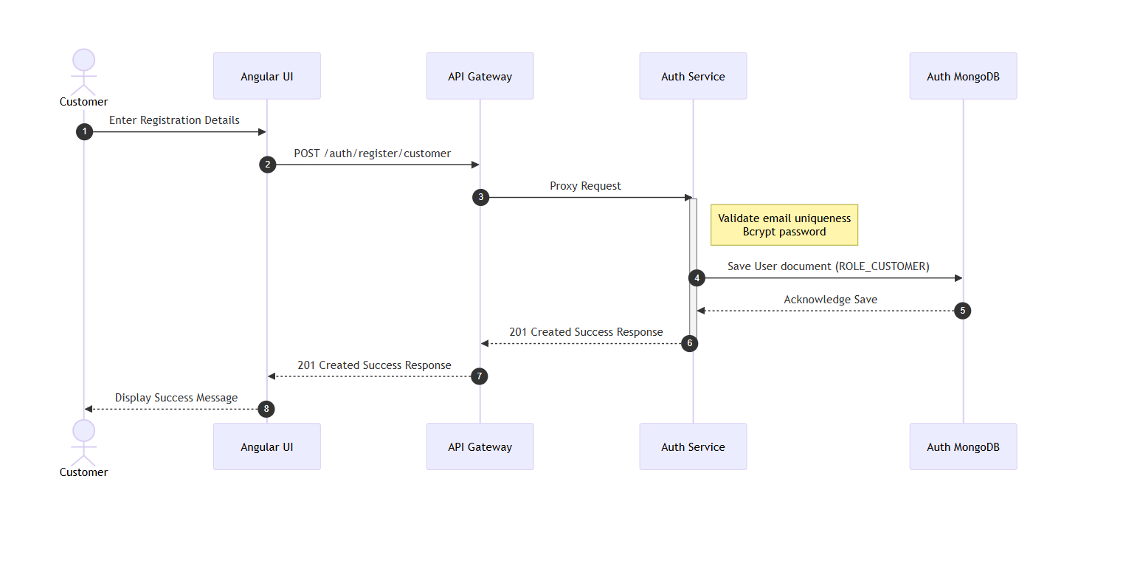

Scenario
A new customer registers an account using the Angular UI.
Flow
- Customer enters registration details (username, email, password) in Angular UI.
- Angular sends POST /auth/register/customer to API Gateway.
- Gateway routes request to Auth Service.
- Auth Service validates request payload (checks if email/username already exists in MongoDB).
- Password is encoded using BCrypt.
- New User document with ROLE_CUSTOMER is saved in Auth MongoDB.
- Success response (e.g., HTTP 201 Created) sent back through Gateway to UI.
Participants
- Customer
- Angular UI
- API Gateway
- Auth Service
- MongoDB (Auth DB)
Key Design Points
- Single entry point via API Gateway.
- Role assignment happens automatically at the service layer based on the endpoint used.
- Password hashing before persistence.

2. User Login (All Roles) — Sequence Diagram
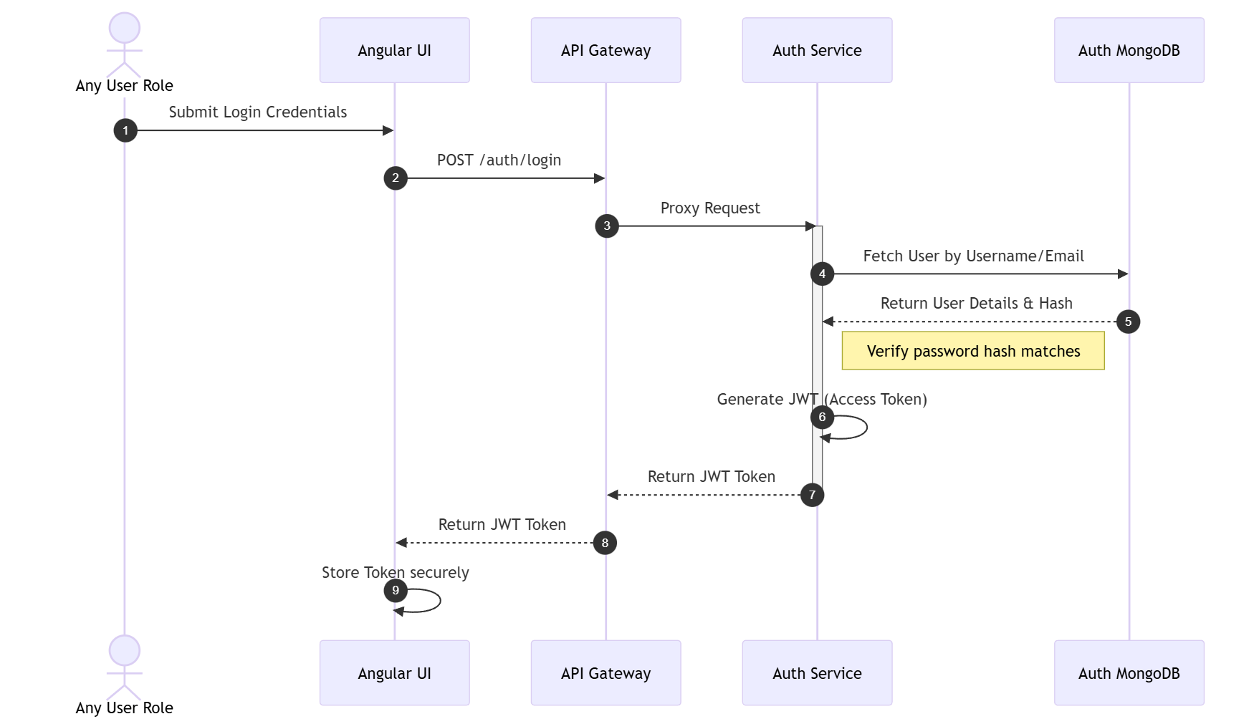

Scenario
A registered user (Customer, Technician, or Manager) logs into the system.
Flow
- User submits credentials in the login form.
- Angular sends POST /auth/login to API Gateway.
- Gateway routes request to Auth Service.
- Auth Service fetches user details via AuthenticationManager from Auth MongoDB.
- Credentials are verified (submitted password matched against stored hash).
- If successful, JWT Access Token containing user ID and Roles is generated.
- Response containing JWT sent back through Gateway to Angular.
- Angular stores the token locally for subsequent authenticated requests.
Participants
- User
- Angular UI
- API Gateway
- Auth Service
- Auth MongoDB
Failure Cases
- Invalid credentials → 401 Unauthorized
- Account locked/disabled → 403 Forbidden

3. Browsing Service Catalog — Sequence Diagram
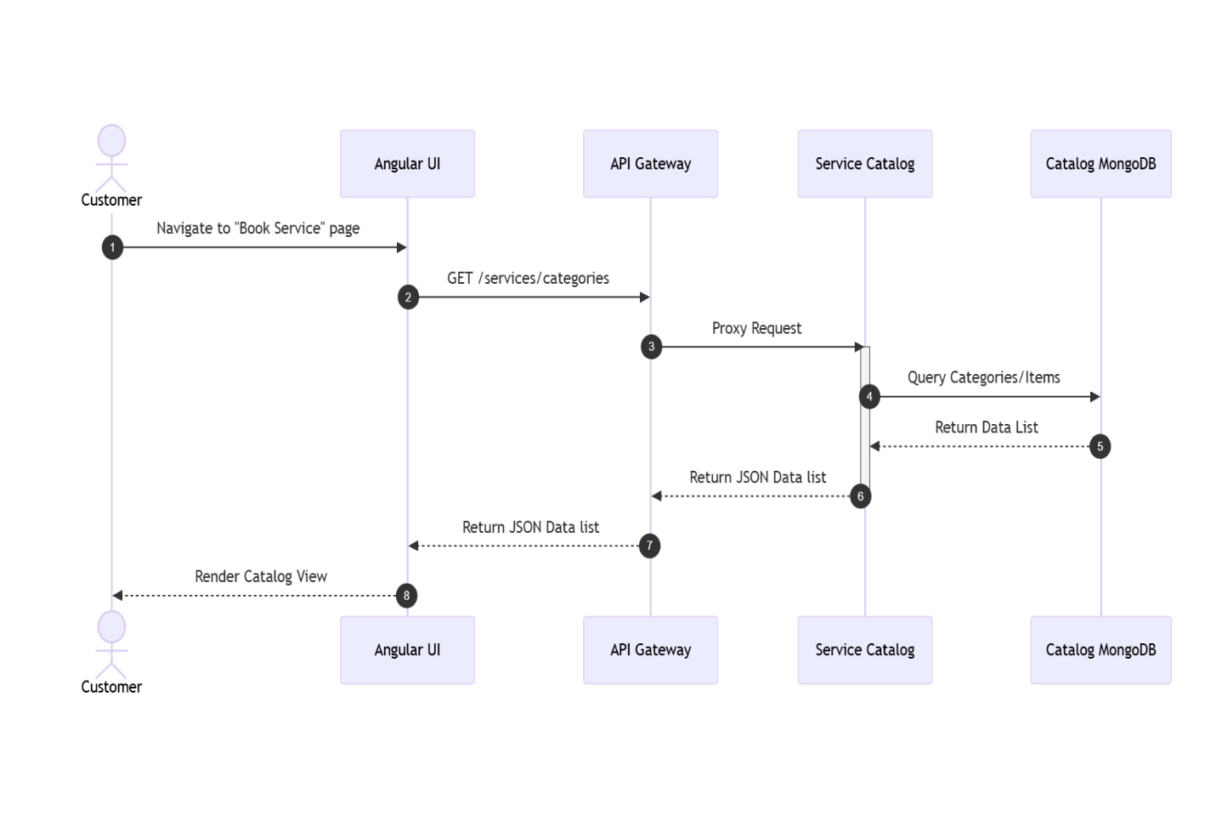

Scenario
A customer views available service categories and items to book.
Flow
- Angular loads the "Book Service" page.
- Angular sends GET /services/categories (or /services/items/{categoryId}) to API Gateway.
- Gateway routes request to Service Catalog.
- Service Catalog queries Catalog MongoDB for requested data.
- List of categories/services returned through Gateway to Angular.
- Angular displays the data in the UI.
Participants
- Customer
- Angular UI
- API Gateway
- Service Catalog
- Catalog MongoDB

4. Booking Creation — Sequence Diagram (MOST IMPORTANT)
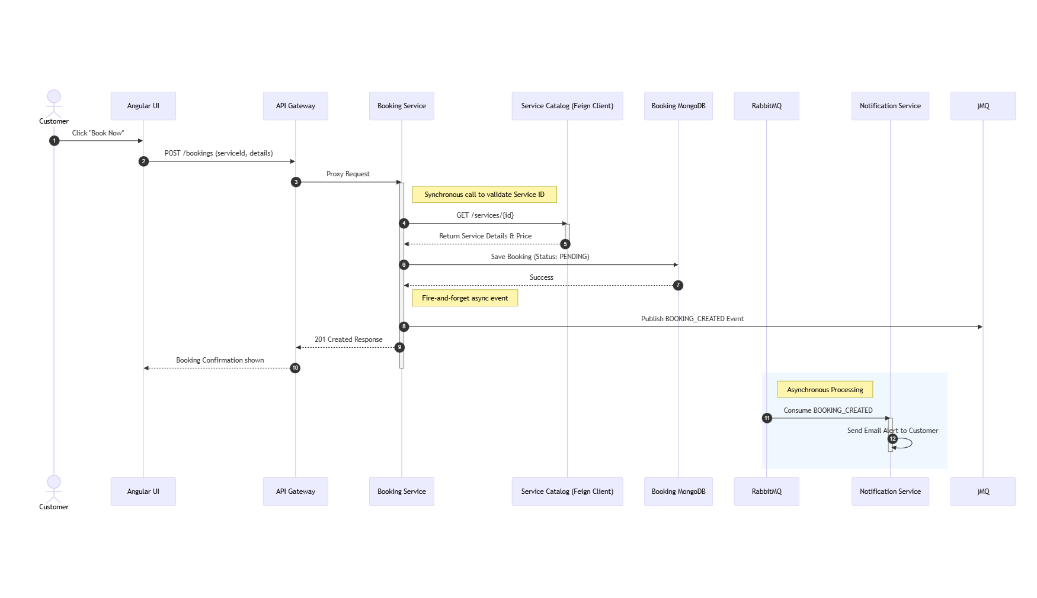

Scenario
A customer selects a service and places a booking request.
Flow
- Customer clicks "Book Now" for a specific service in Angular.
- Angular sends POST /bookings with selected serviceId, date, and address to API Gateway.
- Gateway routes request to Booking Service.
- Booking Service synchronously calls Service Catalog via OpenFeign Client to validate the serviceId and get current pricing.
- Service Catalog returns service details.
- Booking Service creates a new Booking entity with status PENDING and saves it to Booking MongoDB.
- Booking Service asynchronously publishes a BOOKING_CREATED event to RabbitMQ.
- Success response returned to Angular showing booking confirmation.
- (Async) Notification Service consumes the event from RabbitMQ and sends an email alert to the customer.
Participants
- Customer
- Angular UI
- API Gateway
- Booking Service
- Service Catalog (Feign Client)
- Booking MongoDB
- RabbitMQ
- Notification Service
Key Design Decisions
- Synchronous inter-service validation (Feign) to ensure data integrity before creation.
- Asynchronous notification (RabbitMQ) for non-blocking user experience.

5. Technician Assignment by Manager — Sequence Diagram
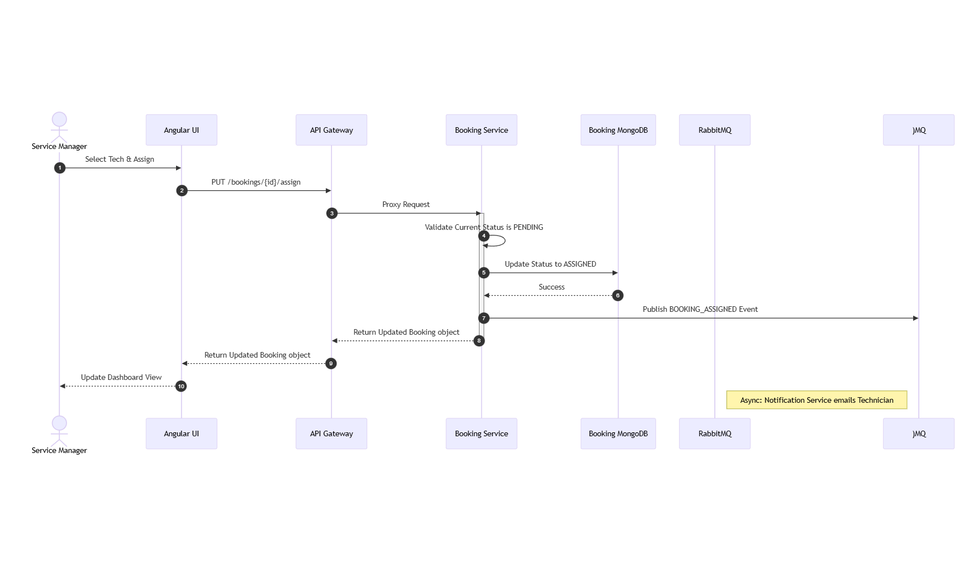

Scenario
A Service Manager assigns a specific technician to a pending booking.
Flow
- Manager views pending bookings in the dashboard and selects a technician for a job.
- Angular sends PUT /bookings/{bookingId}/assign?technicianId={techId} to API Gateway.
- Gateway routes request to Booking Service.
- Booking Service validates that the booking is currently PENDING.
- (Optional but recommended) Booking Service calls Auth Service via Feign to validate the technician ID and check availability.
- Booking Service updates the Booking status to ASSIGNED and sets the technicianId in Booking MongoDB.
- Booking Service publishes BOOKING_ASSIGNED event to RabbitMQ.
- Updated booking details returned to Manager UI.
- (Async) Notification Service consumes event and emails the Technician.
Participants
- Service Manager
- Angular UI
- API Gateway
- Booking Service
- Booking MongoDB
- RabbitMQ
Valid Transitions
- PENDING → ASSIGNED

6. Service Completion & Invoicing — Sequence Diagram
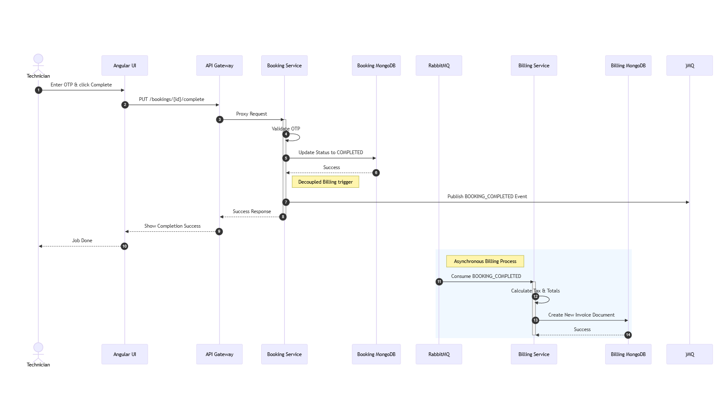

Scenario
A technician completes the service on-site, triggering invoice generation.
Flow
- Technician enters completion details (and optionally customer OTP) in Angular.
- Angular sends PUT /bookings/{id}/complete to API Gateway.
- Gateway routes request to Booking Service.
- Booking Service validates OTP (if applicable).
- Booking Service updates Booking status to COMPLETED in Booking MongoDB.
- Booking Service publishes BOOKING_COMPLETED event containing booking details to RabbitMQ.
- Success response sent to Technician UI.
- (Async) Billing Service consumes the BOOKING_COMPLETED event from RabbitMQ.
- (Async) Billing Service calculates tax/totals and creates a new Invoice in Billing MongoDB.
Participants
- Technician
- Angular UI
- API Gateway
- Booking Service
- Booking MongoDB
- RabbitMQ
- Billing Service
- Billing MongoDB
Key Design Decisions
- Event-driven architecture decouples Booking completion from Billing generation.
- Billing acts as a reactive consumer to booking lifecycle events.

